UNIVERSITY OF PETROLEUM AND ENERGY STUDIES


Student Name: Deepanshi Shukla
Sap ID: - 590021964
Batch: B10
Course: B. Tech (CSE)
SUBJECT: python Programming lab
Experiment: 10
Submitted to:
Kamakshi Rautela

Experiment 10: Data Analysis and Visualization

1. Create numpy array to find sum of all elements in an array.
CODE: -
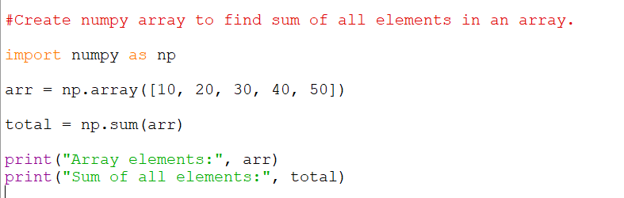
RESULT: -
2. Create numpy array of (3,3) dimension. Now find sum of all rows & columns individually. Also find 2nd maximum element in the array.
CODE: -
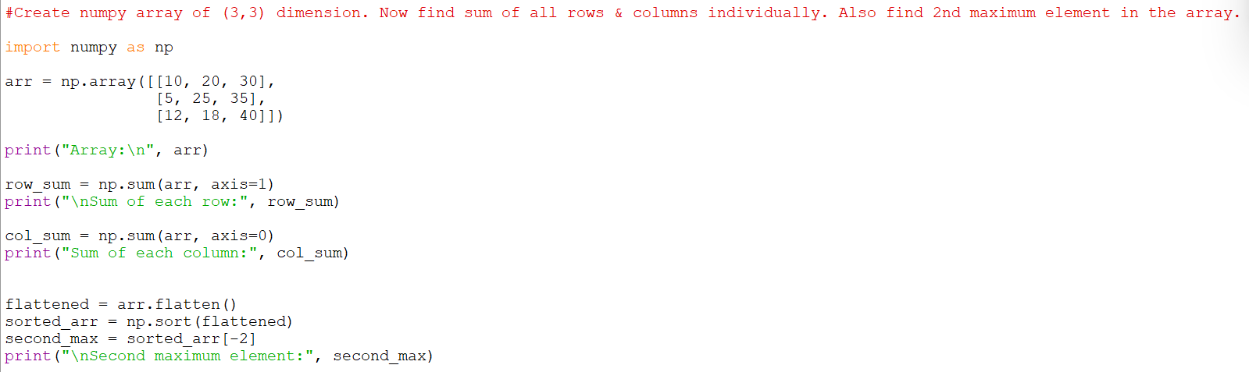
RESULT: -
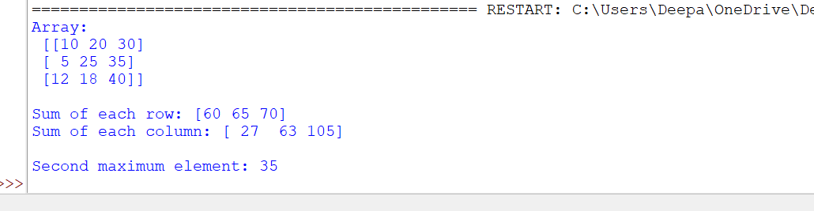
3. Perform Matrix multiplication of any 2 n*n matrices.
CODE: -
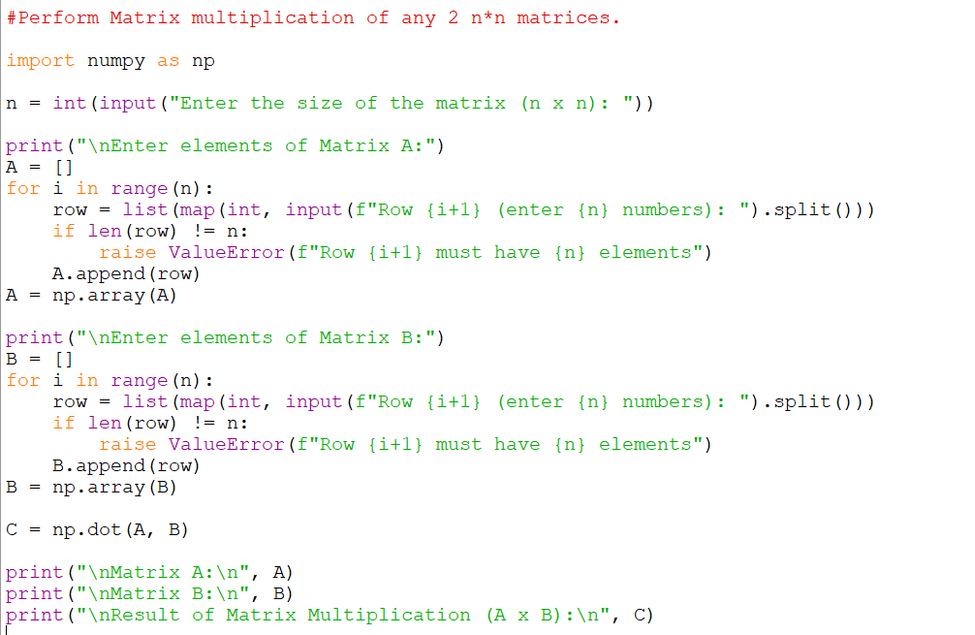
RESULT: -
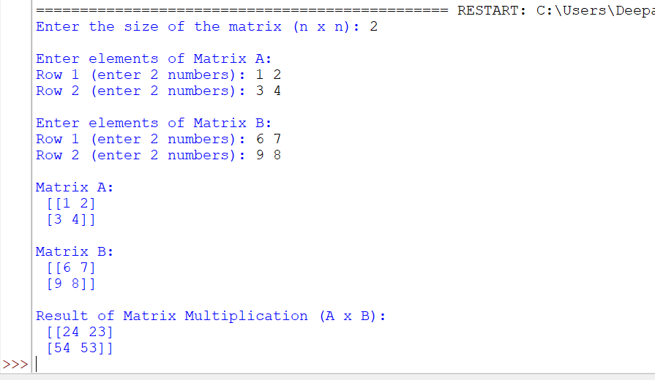
4. Write a Pandas program to get the powers of an array values element-wise.
Note: First array elements raised to powers from second array
Sample data: {'X':[78,85,96,80,86], 'Y':[84,94,89,83,86],'Z':[86,97,96,72,83]}

Expected Output:
X Y Z
0 78 84 86
1 85 94 97
2 96 89 96
3 80 83 72
4 86 86 83
CODE: -
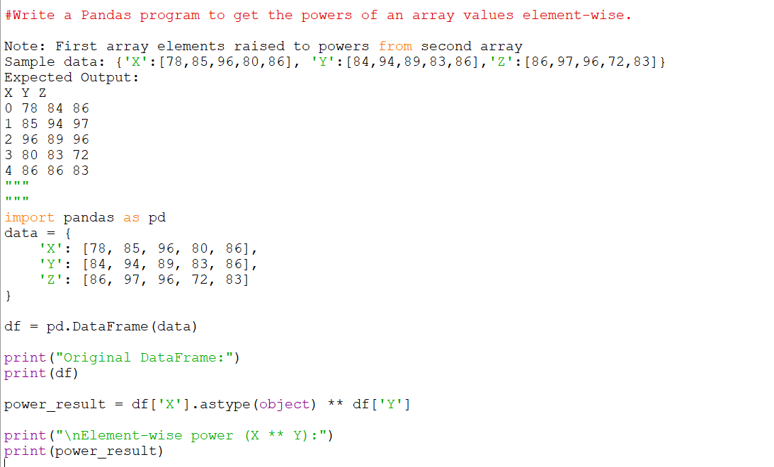
RESULT: -
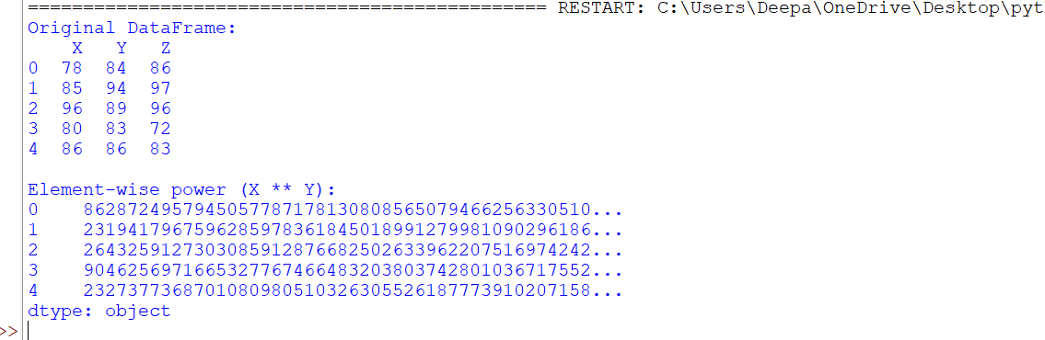

5. Write a Pandas program to get the first 3 rows of a given DataFrame.
Sample Python dictionary data and list labels:
exam_data = {'name': ['Anastasia', 'Dima', 'Katherine', 'James', 'Emily', 'Michael', 'Matthew', 'Laura', 'Kevin', 'Jonas'],
'score': [12.5, 9, 16.5, np.nan, 9, 20, 14.5, np.nan, 8, 19],
'attempts': [1, 3, 2, 3, 2, 3, 1, 1, 2, 1],
'qualify': ['yes', 'no', 'yes', 'no', 'no', 'yes', 'yes', 'no', 'no', 'yes']}
labels = ['a', 'b', 'c', 'd', 'e', 'f', 'g', 'h', 'i', 'j']
Expected Output:
First three rows of the data frame:
attempts name qualify score
a 1 Anastasia yes 12.5
b 3 Dima no 9.0
c 2 Katherine yes 16.5

CODE: -
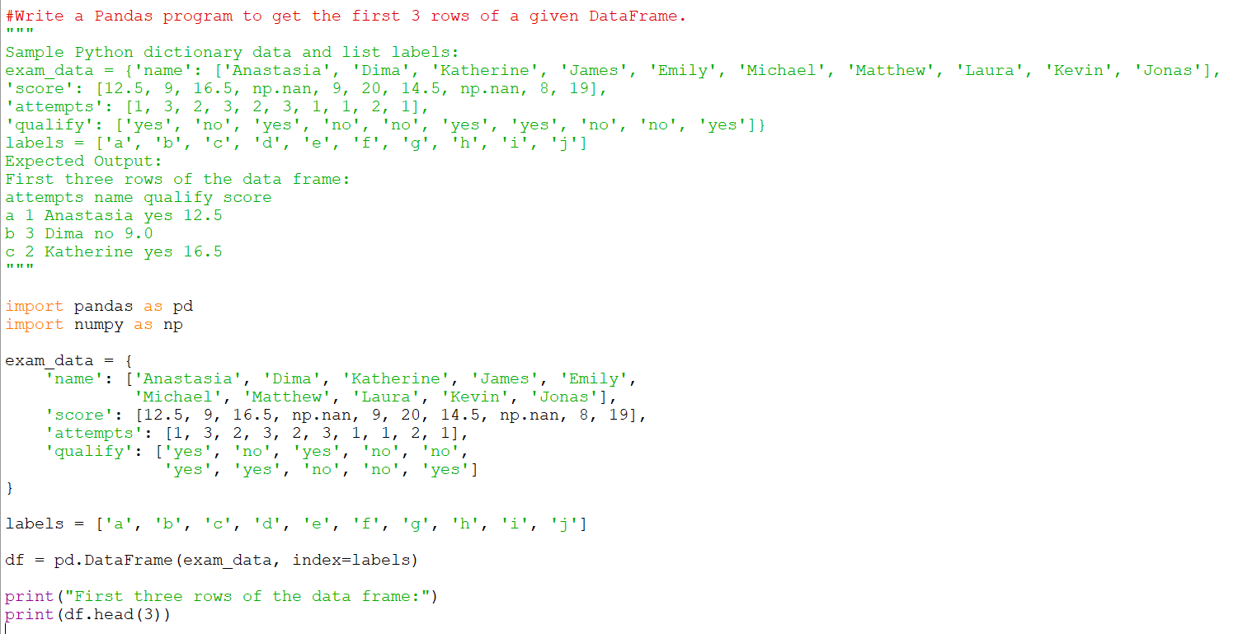
RESULT: -
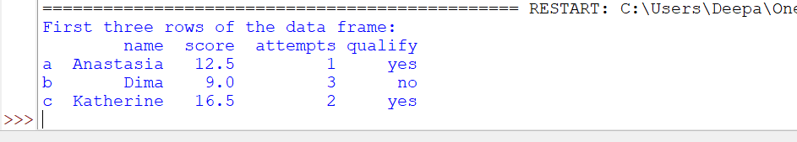
6. Write a Pandas program to find and replace the missing values in a given DataFrame which do not have any valuable information.
Code:-
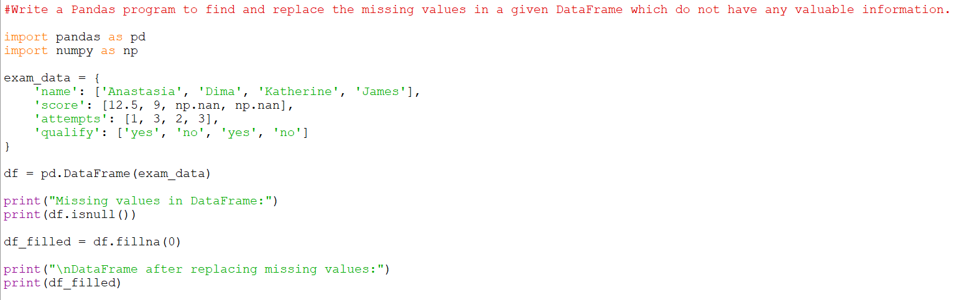

Result:-
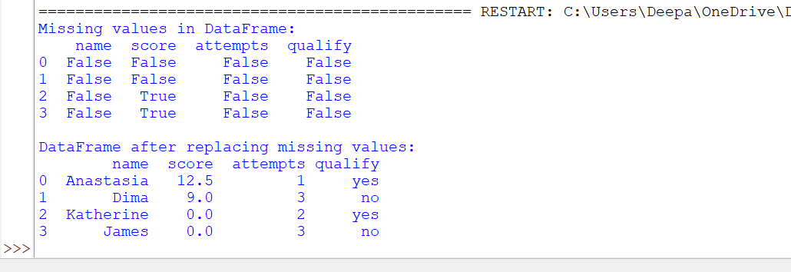
7. Create a program to demonstrate different visual forms using Matplotlib.
Code:-
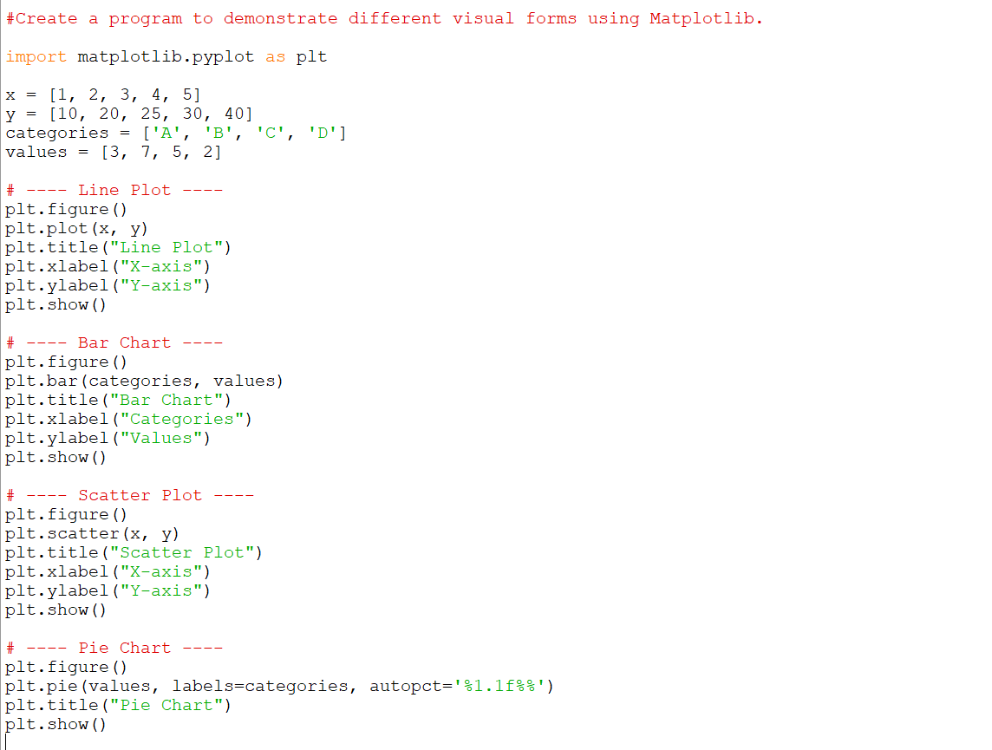
Result:-
